Who are Belle and Sebastian?

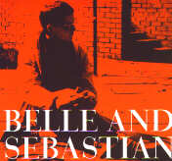

Belle and Sebastian are not two persons that sing, as I first thought when I heard them.
Many people think that the artist name “Belle and Sebastian” comes from the French TV-show “Belle ét Sebastian” witch is about a boy named Sebastian and his dog Belle. Although, Stuart did got some ideas from that, when he later wrote the story about the melancholy boy Sebastian who met the happy girl Belle and how they started to sing together.

There are seven members in the band Belle and Sebastian; Isobel Campbell (cello/song), Richard Colburn (drums), Mick Cooke (trumpet/guitar), Chris Geddes (keyboard), Stevie Jackson (guitar/song), Sarah Martin (violin) and Stuart Murdoch (song/acoustic guitar).

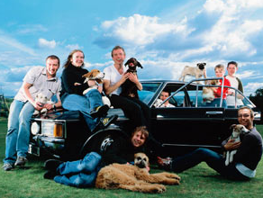

Belle and Sebastian play soft pop music. The tranquil and melancholy intro to “Beautiful” and the bracing music to “Sleep the Clock around” makes you convinced that this band isn’t like any other band. They don’t play that kind of commercial music that plays on and on at the radio. Belle and Sebastian’s lyrics are deeper than that and the music is amazing. Some people say that Belle and Sebastian is a band that you can compare with “The Smiths” or “The Zombies”. I think that Belle and Sebastian play their own kind of music, and that nothing can ever compare with that.

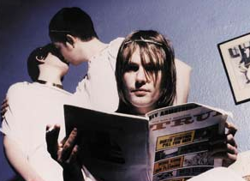

Stuart Murdoch is the main writer, however since the third album Stevie, Isobel and Sarah have all contributed to almost all songs.

Their first legendary gigs were in November 1996, in London on ICA (Institute of Contemporary Arts) as a warm-up band for “Tindersticks” and later at “Borderline”. Those people who were there experienced a religious spirit, according themselves. Belle and Sebastian had a gig in Sweden, this year (2002) in the middle of March in Stockholm.

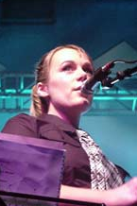

Stuart David and Stuart Murdoch met on a course for unemployment in Glasgow 1995. They decided to record a demo together. When they started to study at the “Stow College” they met Alan Rankie, who worked with Electric Honey Records. When Rankie heard some demos, (The State I Am In) he knew that this duo was something extra. Instead of just do a single, he gave David and Murdoch 3 months to recruit a band to record an album. They recruited
Isobel Campbell, Richard Colburn, Mick Cooke, Chris Geddes and Stevie Jackson. The result became “Tigermilk” and was pressed in one thousand copies. In 1999 “Tigermilk” was released again, but if you’re trying to get the first edition you’ll have to pay almost 600 pounds.

It didn’t took long after the album “Tigermilk” was released for the record company “Jeepster” to contact the band. They wanted to record a new album with Belle and Sebastian. Later that year, in November, “If you’re feeling sinister” was released. The group kept their record company and next following summer they released three EP:s ‘Dog On Wheels’, ‘Lazy Line Painter Jane’ and ‘3..6..9 Seconds Of Light’. The last-mentioned went straight in on “British top 40”.

The popularity made the band more cautious, Stuart Murdoch refused to talk to the press and the band fled from photographers. Nothing could be exploit and they put coloured pictures of their friends on the album cover. Instead of making expensive music videos they just borrowed a video cam and recorded anything they felt for recording that day. If MTV wanted to show that video, fine, it didn’t matter to them.

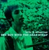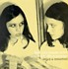

Their third record (Boy With the Arab Strap) was released in 1998 and gave them their biggest commercial success (12:th on the British album top).

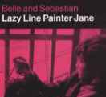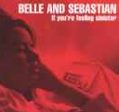

In June 2000 came their latest album, ”Fold your hands child, you walk like a peasant”.

Discography:
1996: Tigermilk (Electric Honey Records)
1996: If You're Feeling Sinister (Jeepster)
1997: Dog On Wheels, EP (Jeepster)
1997: Lazy Line Painter Jane, EP (Jeepster)
1997: 3.. 6.. 9.. Seconds Of Light, EP (Jeepster)
1998: The Boy With The Arab Strap (Jeepster)
1998: This Is Just A Modern Rock Song, EP (Jeepster)
1999: Tigermilk, återutgiven. (Jeepster)
2000: Legal Man, singel (Jeepster)
2000: Fold Your Hands Child, You Walk Like A Peasant (Jeepster)
2001: Sing Jonathan David, EP (Matador)
2001: I'm Waking Up To Us, EP (Matador)

Information and pictures taken from:
http://www.revolver.nu/por_belleandsebastian.php
Nationalencyklopedin
http://www.google.com
http://www.partyversum.se/records/show.asp?ID=54
http://www.jeepster.co.uk/belleandsebastian/

By: Elisabeth Carlsson 2002-05-02

Dictionary:
Found = bilda
Warm-up band = förband
According = enligt
Recruit = rekrytera
Cautious = aktsam, förtänksam.
Exploit = exploatera
Edition = utgåva
Contribute = lämna bidrag, medverka.
Extract = utdrag

